**TITLE OF PROJECT**

FACE MASK DETECTION

**A Project Report**

**Submitted by:**

ABHISHEK GOSWAMI

JOYAL.S.PALACKEL

BHARAT KHARBANDA

SHUBHAM TONGARIA

**ENGINEERING STUDENTS OF**



**SHARDA UNIVERSITY**

**Knowledge Park III, Greater Noida, Uttar Pradesh 201310**

**Table of Contents**

|  |  |  |
| --- | --- | --- |
|  |  |  |
|  | Title Page | 3 |
|  | Declaration of the Student | 4 |
|  | Abstract | 5 |
|  | Acknowledgement | 6 |
|  | List of Figures | 7 |
|  | Gantt Chart | 8 |
|  | Graphs  F1 Score  Epoch | 9  10  10 |
|  |  |  |
| **1.** | **INTRODUCTION** |  |
|  | * 1. Problem Definition   2. Project Overview   3. Hardware Specification   4. Software Specification | 11  12  13  13 |
|  |  |  |
| **2.** | **LITERATURE SURVEY** |  |
|  | 2.1 Existing System  2.2 Proposed System | 14  14 |
|  |  |  |
| **3.** | **SYSTEM ANALYSIS & DESIGN** |  |
|  | 3.1 Requirement Specification  3.2 DFD  3.3 Pseudo Code | 15  16  17 |
|  |  |  |
| **4.** | **OUTPUTS** | 18 |
| **5.** | **CODE** | 19 |
|  |  |  |
| **6.** | **REFERENCES** | 23 |
|  |  |  |



Face Mask Detection

Algorithm

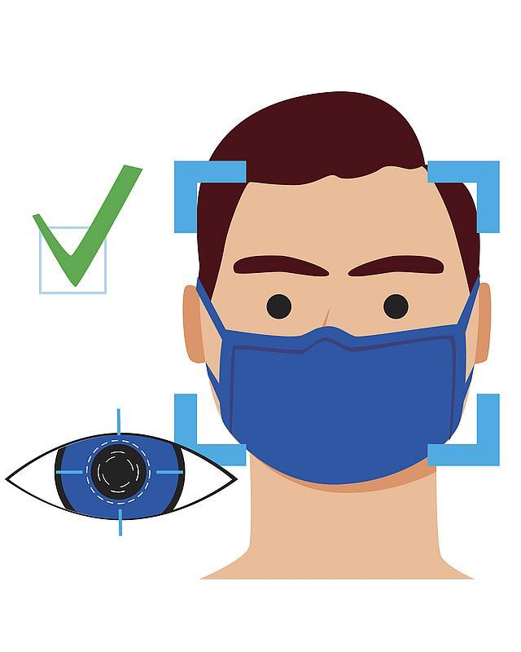

**DECLARATION OF STUDENT**

We hereby declare that the project report entitled “FACE MASK DETECTION” submitted in Hackathon “**Code Innovation Series**” hosted by **GitHub**, by the above mentioned team members.

**ABSTRACT**

As we all know that the [**coronavirus (COVID-19) outbreak came to light**](https://www.thehindu.com/sci-tech/health/a-new-virus-emerges-in-china/article30567853.ece) when on December 31, 2019, China informed the World Health Organization (WHO) of a cluster of cases of pneumonia of an unknown cause in Wuhan City in Hubei province. On January 9, 2020, the WHO issued a statement saying Chinese researchers have made “preliminary determination” of the virus as a novel coronavirus.

In order to prevent themselves from the disease everyone wears a mask during the COVID-19 coronavirus epidemic. Almost everyone wears a mask during coronavirus epidemic. This almost makes conventional facial recognition technology ineffective in many cases, such as community access control, face access control, facial attendance, facial security checks at train stations, etc. Therefore, it is very urgent to improve the recognition performance of the existing face recognition technology on the masked faces. Most current advanced face recognition approaches are designed based on deep learning, which depend on a large number of face samples. However, at present, there are no publicly available masked face recognition datasets. To this end, this work proposes three types of masked face datasets, including Masked Face Detection Dataset, Real-world Masked Face Recognition Dataset and Simulated Masked Face Recognition Dataset . Among them, to the best of our knowledge, Real-world Masked Face Recognition Dataset is currently the world’s largest real-world masked face dataset. These datasets are freely available to industry and academia, based on which various applications on masked faces can be developed. The multigranularity masked face recognition model we developed achieves 95% accuracy, exceeding the results reported by the industry.

**ACKNOWLEDGEMENT**

The success and final outcome of this project required a lot of guidance and assistance from many people. Whatever we have done is only due to such guidance and assistance and we would not forget to thank them. We respect and thank our teachers, seniors and for guiding us. This project cannot be completed without the effort and co-operation from our group members. Last but not least, we would like to express our gratitude to our friends and respondents for support and willingness to spend some time with us.

**LIST OF FIGURES**

1. GANTT CHART
2. DATA FLOW DIAGRAM
3. OUTPUT IMAGES
4. GRAPHS
5. F1 Score
6. Epoch

**GANTT CHART**

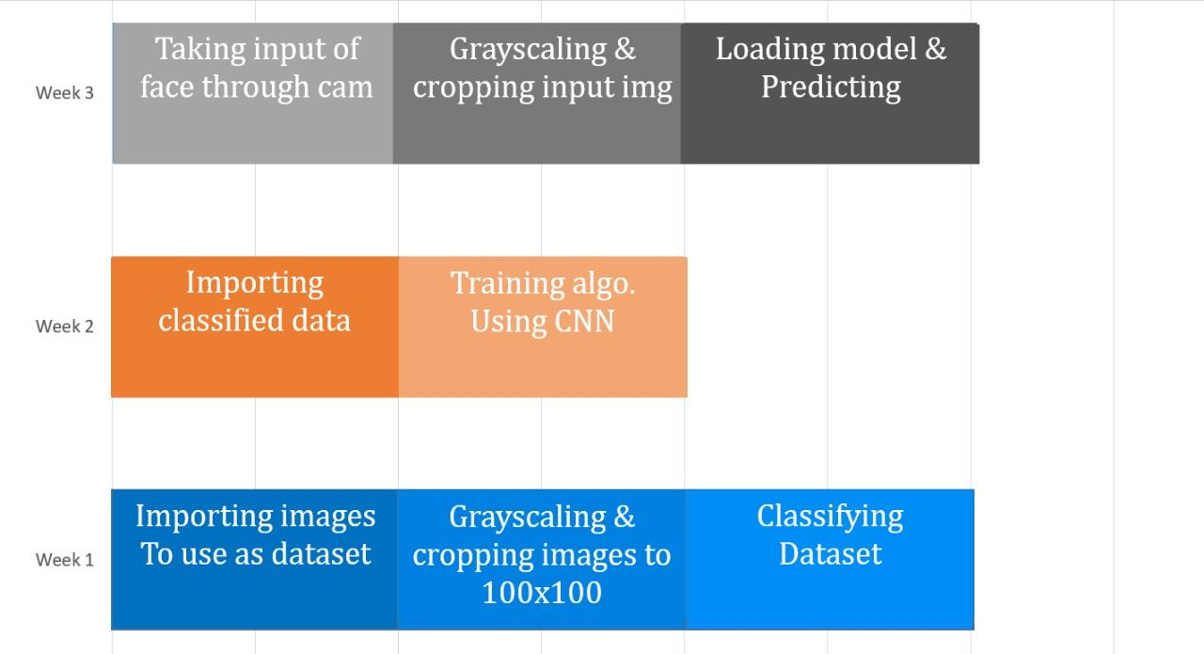

**Graphs**

1. 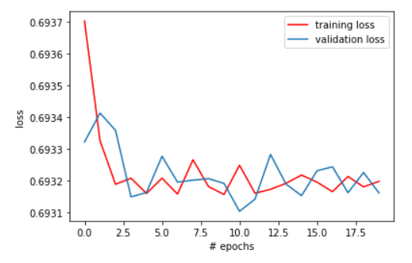**Graph of Loss**
2. **Graph of Accuracy**

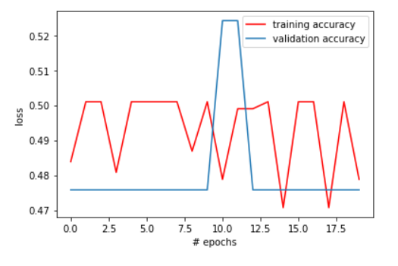

1. 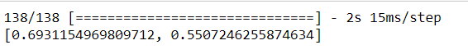**F1 Score**
2. 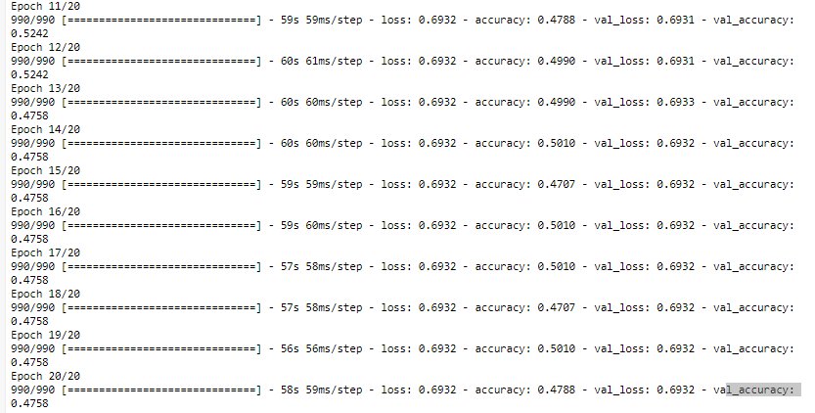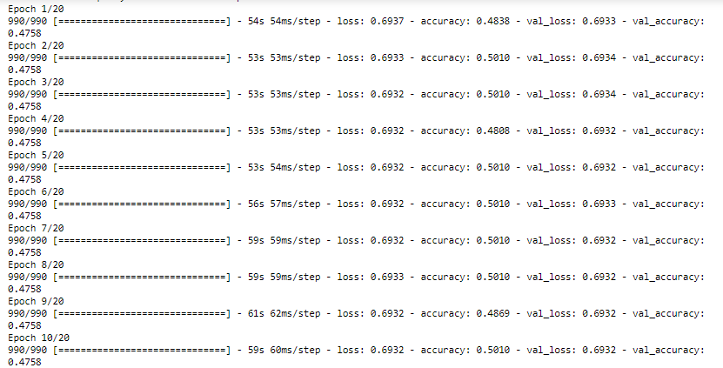**Epoch**

**INTRODUCTION**

**Problem Definition**

Coronavirus has now become the talk of town . In order to efficiently prevent the spread of COVID 19 virus , healthcare officials have suggested people to wear mask , as masks can help prevent the spread of the virus from the person wearing the mask to others. This almost makes conventional facial recognition technology ineffective in many cases, such as community access control, face access control, facial attendance, facial security checks at train stations, etc.

Hence , to further help in preventing the spread of COVID-19 virus , this project can be used for real time face mask detection using webcam with an impressive accuracy.

Our project on face mask detection , deals on how computer vision and deep learning can be implemented . In this project , we are going to make a COVID-19 face mask detector with Keras and deep learning . We are using Python Script to make this face mask detector. The script is additionally divided into two parts:-

1- Detect COVID-19 face masks from image

2- Detect face mask in a real-time video streams.

**PROJECT OVERVIEW**

Face detection has emerged as a very interesting problem in image processing and computer vision. It has a range of applications from the facial motions capture to face recognition which at the start needs the face to be detected with a good accuracy. Face mask detection is more relevant because it not only used on images but also in video applications like real time surveillance and face detection in videos.

High accuracy image classification in possible now with the advancement of Convolution networks. Pixel level information is often required after face detection which most face detection methods fail to provide.

As we know the current popular face masks, there are two closely related and different applications, namely,facial mask detection task and masked face recognition task. Face mask detection task needs to identify whether a person wear a mask as required. Masked face recognition task needs to identify the specific identity of a person with a mask. Each task has different requirements for the dataset. The former only needs masked face image samples, but the latter requires a dataset which contains multiple face images of the same subject with and without a mask. Relatively, datasets used for the face recognition task are more difficult to construct. In order to handle masked face recognition task, this paper proposes three types of masked face datasets, including Masked Face Detection Dataset (MFDD), Real-world Masked Face Recognition Dataset (RMFRD) and Simulated Masked Face Recognition Dataset (SMFRD).

We focused on the edge and grey value of face image and this was based on pattern recognition model, having a prior information of the face model. Our proposed masked face recognition technique has been

blessed with two aspects. One is the built dataset, and the other is the full use of uncovered useful face features. We took advantages of the existing public face recognition datasets, and combined them with the self-built simulated masked faces as well as the masked faces from actual scenes as the final dataset to train a face-eye-based multi-granularity recognition model.

There are also a large number of controlled application scenarios, such as mask checks in work places, security checks at train stations etc. In these situations, subjects are usually in a cooperative manner, typically, approaching and facing up the camera. Thus high-quality frontal face images are readily acquired, so that the masked face recognition task is no longer so difficult.

**HARDWARE SPECIF****ICATIONS**

Web Camera

Using your webcam, the script applies face mask detection to every frame in the stream

IR Thermometer

Lock system

**SOFTWARE SPECIFICATIONS**

Python 3.5–3.8

Ubuntu 16.04 or later (64-bit)

or

macOS 10.12.6 (Sierra) or later (64-bit) **(no GPU support)**

or

Windows 7 or later (64-bit)

[Microsoft Visual C++ Redistributable for Visual Studio 2015, 2017 and 2019](https://support.microsoft.com/help/2977003/the-latest-supported-visual-c-downloads)

Raspbian 9.0 or later

**LITERATURE SURVEY**

**Existing System**

In the current market there exist facial recognition system.

A facial recognition system is a technology capable of identifying or verifying a person from a digital image or a video frame from a video source. There are multiple methods in which facial recognition systems work, but in general, they work by comparing selected facial features from given image with faces within a database. It is also described as a Biometric Artificial Intelligence based application that can uniquely identify a person by analyzing patterns based on the person's facial textures and shape.

**Proposed System**

This algorithm would scan the person’s face and categorize them whether they are wearing face masks or not for precaution. Any organisation could use this algo according to their use like:

Giving entry to their compound based on whether a person is wearing a mask or not.

Automating the process of imposing fine for not wearing mask.

**SYSTEM ANALYSIS & DESIGN**

**Requirement Specification**

**OpenCV**

OpenCV is a library of programming functions mainly aimed at real-time computer vision. Originally developed by Intel, it was later supported by Willow Garage then Itseez. The library is cross-platform and free for use under the open-source BSD license.

**Keras**

Keras is an open-source neural-network library written in Python. It is capable of running on top of TensorFlow, Microsoft Cognitive Toolkit, R, Theano, or PlaidML. Designed to enable fast experimentation with deep neural networks, it focuses on being user-friendly, modular, and extensible.

**TensorFlow**

TensorFlow is a free and open-source software library for dataflow and differentiable programming across a range of tasks. It is a symbolic math library, and is also used for machine learning applications such as neural networks.

**DATA FLOW** **DIAGRAM (DFD)**

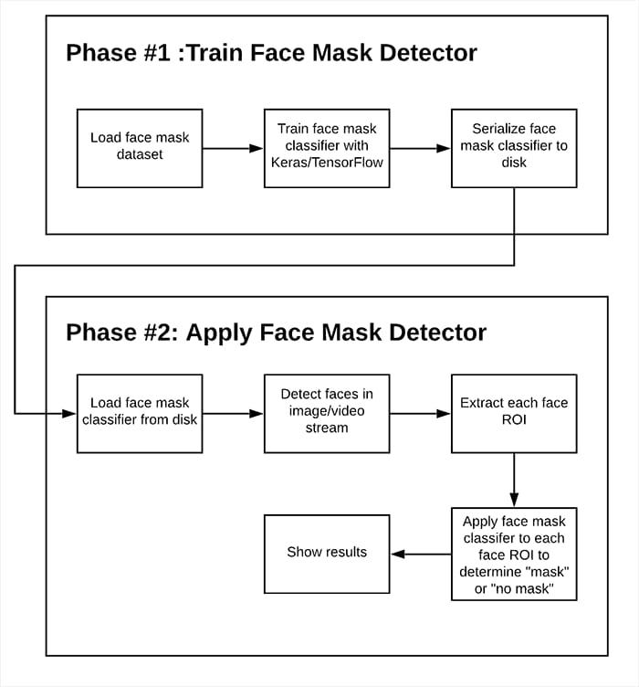

**PSEUD****O CODE**

STEPS DISCRIPTION

1. Import data for dataset

2. Grayscaling images and cropping them to 100x100

3. Classifying images as masked or unmasked

4. Storing this data.

5. Importing back the classified data to train the algorithm.

6. We use CNN with 2 layers

7. Flatten and dense the result and make 2 nodes masked & unmasked respectively.

8. Taking live input using camera.

9. Predicting the result using trained algorithm.

**OUTPUT**

**WITHOUT MASK**

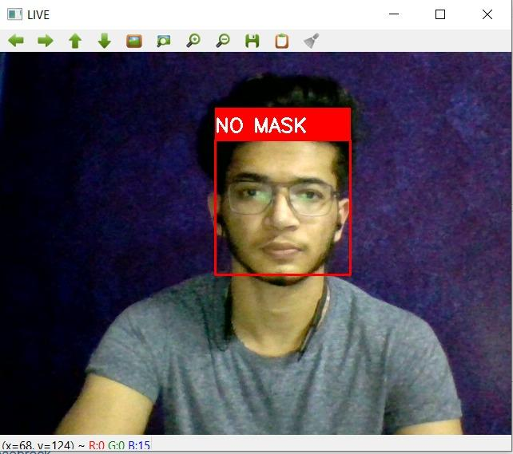

**WITH MASK**

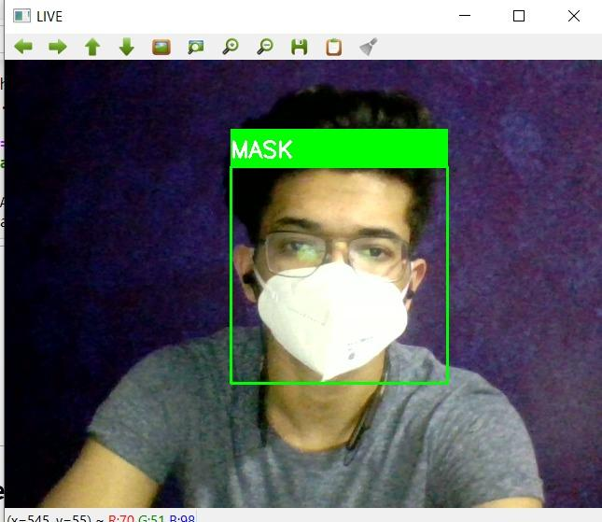

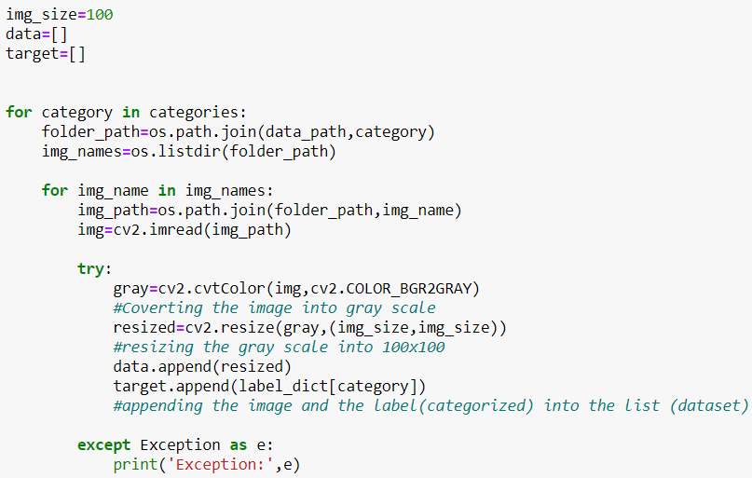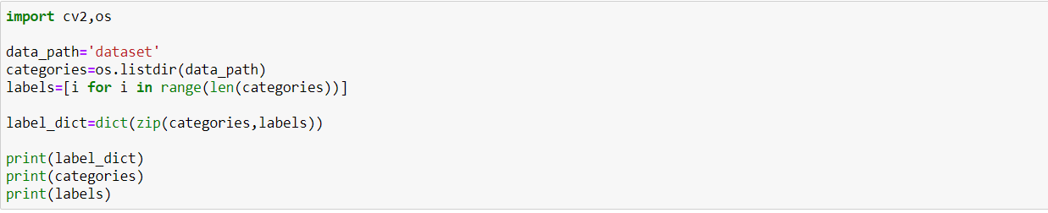**CODE**

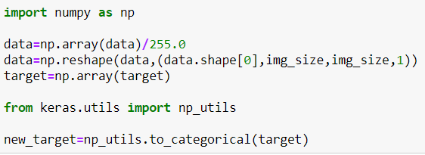



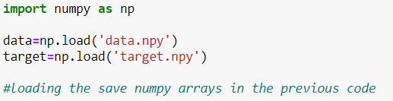

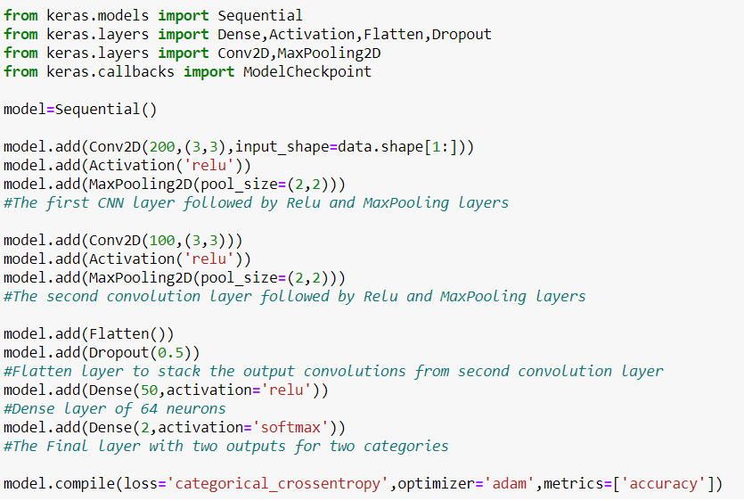



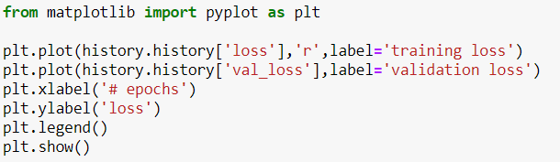

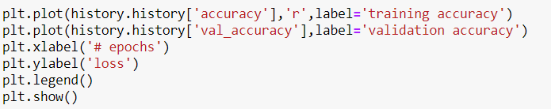



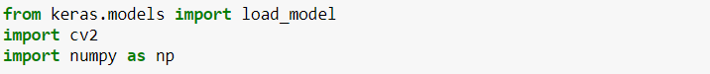

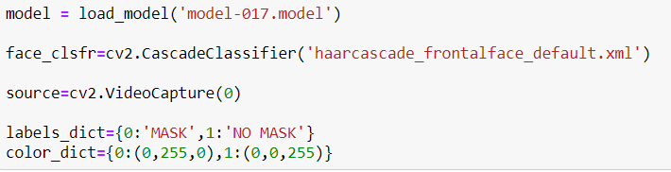

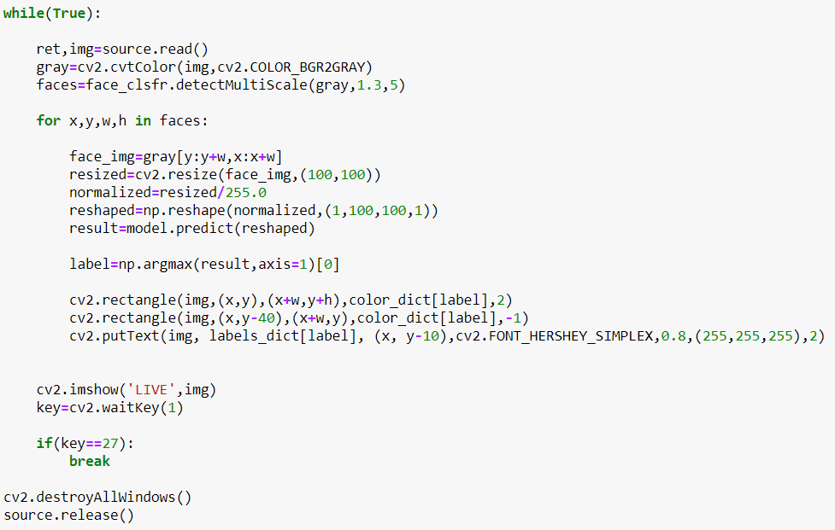

**REFERENCE**

* **Pyimagesearch**
* **Machine Learning By Andrew NG**
* **CNN Course from Tensorflow**
* **Seniors doing the similar kind of project**
* **Keras and Tensorflow Course in Coursera**